InComm

EMS Configuration

Version 1.1

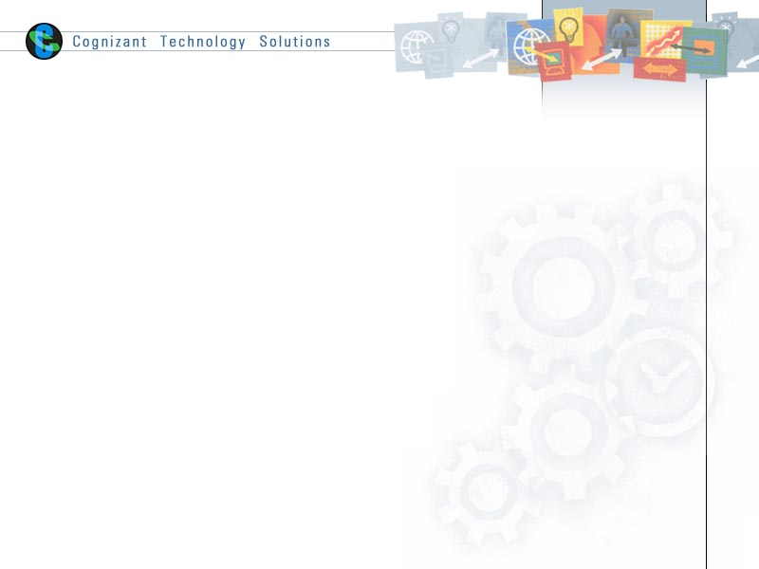

|  |  |  |  |
| --- | --- | --- | --- |
|  | **Prepared By / Last Updated By** | **Reviewed By** | **Approved By** |
| **Name** | Yogesh Basavarajaiah |  |  |
| **Role** |  |  |  |
| **Signature** | Yogesh Basavarajaiah |  |  |
| **Date** | June 8, 2015 |  |  |

Table of Contents

1.0 Document Overview 3

1.1 Document Purpose 3

1.2 References 3

1.3 Definitions, Acronyms and Abbreviations 3

2.0 EMS Architecture 3

3.0 Install EMS server 4

4.0 Configuration on EMS server 4

4.1 Common DataStore Configuration. 4

4.2 Edit tibemsd.conf 4

4.3 Edit FT Configuration 5

5.0 Start EMS Servers 6

6.0 Create Queues 6

7.0 Updates in TIBCO BW Code 6

8.0 Appendix A – Change Log 7

# Document Overview

## Document Purpose

This document is intended to provide guideline on EMS Configuration for QA environment.

## References

Use this section to fill-in reference documents used

|  |  |
| --- | --- |
| ***Document#*** | ***Document Title*** |
|  |  |
|  |  |

## Definitions, Acronyms and Abbreviations

Use this section to fill-in definitions of acronyms & abbreviations used in this document

|  |  |
| --- | --- |
| ***Term, Acronym*** | ***Definition*** |
|  |  |
|  |  |

# EMS Architecture

This is the snippet from InComm Architecture Document shared earlier, depicting EMS servers in FT mode.

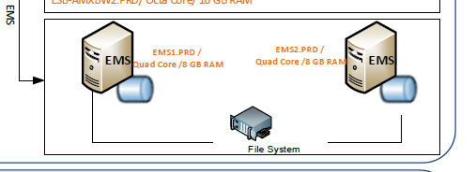

# Install EMS server

Install EMS Server on two machines (for eg: **QATIBWEB01F & QATIBWEB02F)**.

Below steps briefs on installation steps.

* Open the console and navigate to the location where ems 7.0 .tar file exists.
* Extract the .tar to a temporary location.
* Launch the Xming just to see the installation process in GUI mode.
* Navigate to the temporary directory that contains the universal installer and run the below command.

./ **TIBCOUniversalInstaller.sh**

* In the Xming it opens a welcome page. Click Next.
* Accept the license agreement and click next.
* It then opens installation screen. Click next.
* In next screen select the existing BW6 home. Click next.
* Click next for the next screen.
* Click install.
* Wait for the installation to finish and once installation is done just click finish to close the installer.

# Configuration on EMS server

## Common DataStore Configuration.

It is required to configure EMS datastore and other conf files common between the two EMS servers to operate in FT mode.

1. It is recommended to have a common File sharing system. (NAS or SAN), where datastore and conf files can be accessed by these two servers.
2. If common share is not available, it is necessary to have these two machines to have access to a common directory in one of the machines, for FT setup to operate.
3. Copy the following files to the common shared location. Copy the whole “data” folder
   1. From : <<EMS_CONFIG_HOME>\data (Eg:C:\ProgramData\TIBCO\tibco\cfgmgmt\ems\data)
   2. To : Common share location (\\commonsharelocation\tibco\cfgmgmt\ems\data)

## Edit tibemsd.conf

Make sure the tibemsd.conf file in both the servers are pointing to the right set (common datastore configuration done in the previous step) of datafiles and other .conf files. The below steps are applicable for both the servers **QATIBWEB01F & QATIBWEB02F.**

1. Copy tibemsd.conf file
   1. From : <<EMS_HOME>>\samples\config directory\tibemsd.conf

(Eg: C:\tibco\ems\7.0\samples\config)

* 1. To : <<EMS_HOME>>\bin\ tibemsd.conf (make a copy of the file if any existing already)

(Eg: C:\tibco\ems\7.0\bin)

1. Edit the entries in the file as shown below

users = \\commonsharelocation\tibco\cfgmgmt\ems\data\users.conf

groups = \\commonsharelocation\tibco\cfgmgmt\ems\data\groups.conf

topics = \\commonsharelocation\tibco\cfgmgmt\ems\data\topics.conf

queues = \\commonsharelocation\tibco\cfgmgmt\ems\data\queues.conf

acl_list = \\commonsharelocation\tibco\cfgmgmt\ems\data\acl.conf

factories = \\commonsharelocation\tibco\cfgmgmt\ems\data\factories.conf

routes = \\commonsharelocation\tibco\cfgmgmt\ems\data\routes.conf

bridges = \\commonsharelocation\tibco\cfgmgmt\ems\data\bridges.conf

transports = \\commonsharelocation\tibco\cfgmgmt\ems\data\transports.conf

tibrvcm = \\commonsharelocation\tibco\cfgmgmt\ems\data\tibrvcm.conf

durables = \\commonsharelocation\tibco\cfgmgmt\ems\data\durables.conf

channels = \\commonsharelocation\tibco\cfgmgmt\ems\data\channels.conf

stores = \\commonsharelocation\tibco\cfgmgmt\ems\data\stores.conf

## Edit FT Configuration

1. Server 1 (QATIBWEB01F)
2. Navigate to <<EMS_HOME>>\bin\ tibemsd.conf
3. Edit the file as shown below

store = \\commonsharelocation\tibco\cfgmgmt\ems\data\datastore

ft_active = tcp:// QATIBWEB02F:7222

ft_heartbeat = 3

ft_activation = 60

ft_reconnect_timeout = 60

1. Server 2 (QATIBWEB02F)
2. Navigate to <<EMS_HOME>>\bin\ tibemsd.conf
3. Edit the file as shown below

store = \\commonsharelocation\tibco\cfgmgmt\ems\data\datastore

ft_active = tcp:// QATIBWEB01F:7222

ft_heartbeat = 3

ft_activation = 60

ft_reconnect_timeout = 60

1. Edit factories.conf in common share location (\\commonsharelocation\tibco\cfgmgmt\ems\data\factories.conf)

[FTTopicConnectionFactory]

type = topic

url = tcp:// QATIBWEB01F:7222,tcp:// QATIBWEB02F:7222

[FTQueueConnectionFactory]

type = queue

url = tcp:// QATIBWEB01F:7222,tcp:// QATIBWEB02F:7222

# Start EMS Servers

1. Start EMS server with the configuration server in QATIBWEB01F

./tibemsd64 -config <<EMS_HOME>>\bin\ tibemsd.conf

(Eg: ./tibemsd64 -config /opt/tibco/bw6/ems/7.0/bin/tibemsd.conf)

1. Start EMS server with the configuration server in QATIBWEB02F

./tibemsd64 -config <<EMS_HOME>>\bin\ tibemsd.conf

(Eg: ./tibemsd64 -config /opt/tibco/bw6/ems/7.0/bin/tibemsd.conf)

1. Confirm logfile entries for appropriate startup of servers with one primary and another stand-by)



# Create Queues

1. To create 2 queues in same EMS server, below are the 2 queues to be created:

create queue COM.INCOMM.COM.SHAREDSERVICES.ERRORHANDLING.EXCEPTIONQUEUE

create queue COM.INCOMM.COM.SHAREDSERVICES.ERRORHANDLING.LOGQUEUE

# Updates in TIBCO BW Code

Update the module property for JMS connection and just specify queue connection factory ‘FTQueueConnectionFactory’ and topic connection factory ‘FTTopicConnectionFactory’

# Appendix A – Change Log

|  |  |  |  |  |
| --- | --- | --- | --- | --- |
| ***Version Number*** | ***Changes Made*** | | | |
| V1.0 | Initial baseline created on June 8, 2015 | | | |
| V1.1 |  | | | |
| **Section No.** | **Changed By** | **Effective Date** | **Changes Effected** |
| N/A | Dwiz Kumar | June 19, 2015 | Added Sec 3,4.3, 5 & 7 |
| Vx.y |  | | | |
| **Section No.** | **Changed By** | **Effective Date** | **Changes Effected** |
| N/A | Vinay Honnavara B | June 19, 2015 | Added sec 2,4.1 & 4.2 |
| Vx.y |  | | | |
| **Section No.** | **Changed By** | **Effective Date** | **Changes Effected** |
|  |  |  |  |